1. GitHub Setup — Fork & Personal Access Token
1.1 Fork the Repository
Go to the source repository on GitHub: https://github.com/amitopenwriteup/nginx-argoproj
- Click the Fork button (top-right corner of the page).
- Select your own GitHub account as the owner.
- Click Create fork. You now have your own copy at: https://<your-username>/nginx-argoproj
1.2 Generate a Personal Access Token (PAT)
ArgoCD will connect to your forked GitHub repo over HTTPS using a PAT for authentication.
- Go to GitHub → Settings → Developer Settings → Personal Access Tokens → Tokens (classic)
- Click Generate new token (classic).
- Enter a descriptive name, e.g. argocd-workshop-pat
- Set expiration to 30 days (or as needed).
- Select scopes — check repo (full repository access).
- Click Generate token and copy the token immediately. You will not see it again.
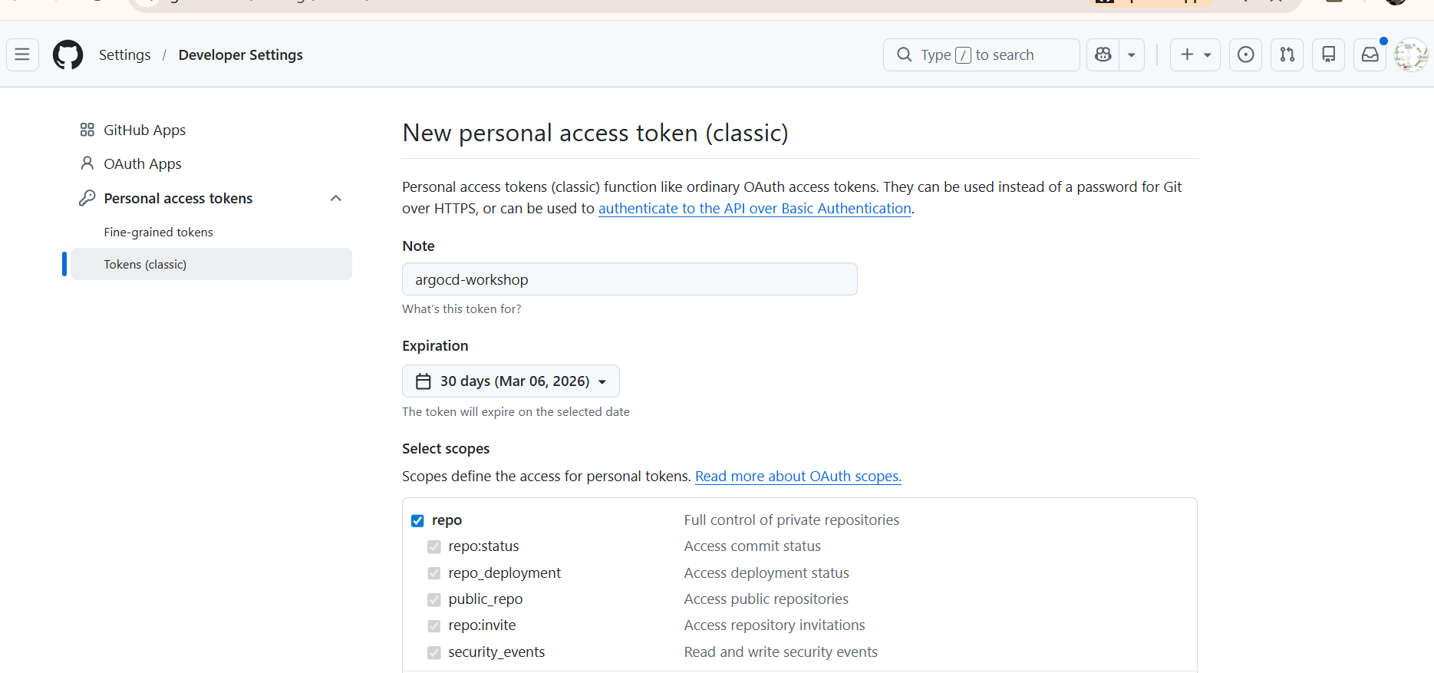

6. Create an ArgoCD Project
Projects in ArgoCD allow you to group applications, enforce access controls, and restrict source/destination clusters and namespaces.
6.1 Via the ArgoCD UI
- Go to Settings → Projects
- Click Create Project

Register GitHub Repo in ArgoCD
In the ArgoCD UI, navigate to Settings → Repositories → Connect.
Field | Value
Field | Value
Type | HTTPS
Repository URL | https://github.com/<your-username>/nginx-argoproj.git
Username | Your GitHub username
Password | The PAT you just generated
Click Connect. A green success indicator confirms the repo is linked.

